Lab-6 Report
SOP Implementation with 4:1 Multiplexer

MIRIYALA PRANAY KAMAL
200030033

Aim: Implement following SOP with 4:1 MUX. Treat A, B as select lines (S₁,S₀).

Y = f(A, B, C, D) = Σm(3,5,7,10,12,15) + d(9,11,13,14)

Components used:

- Digital MUX DM74153
- Digital AND gate 7408
- Power supply
- Breadboard
- 1k resistor arrays (X2)
- LED display
- DIP switches

Diagram of 4:1 MUX:

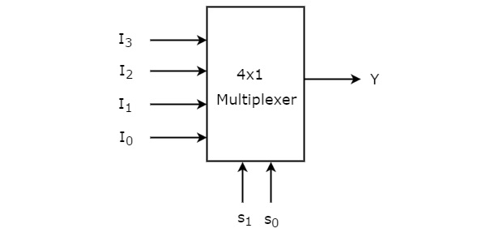

Design Procedure & Circuit diagram:

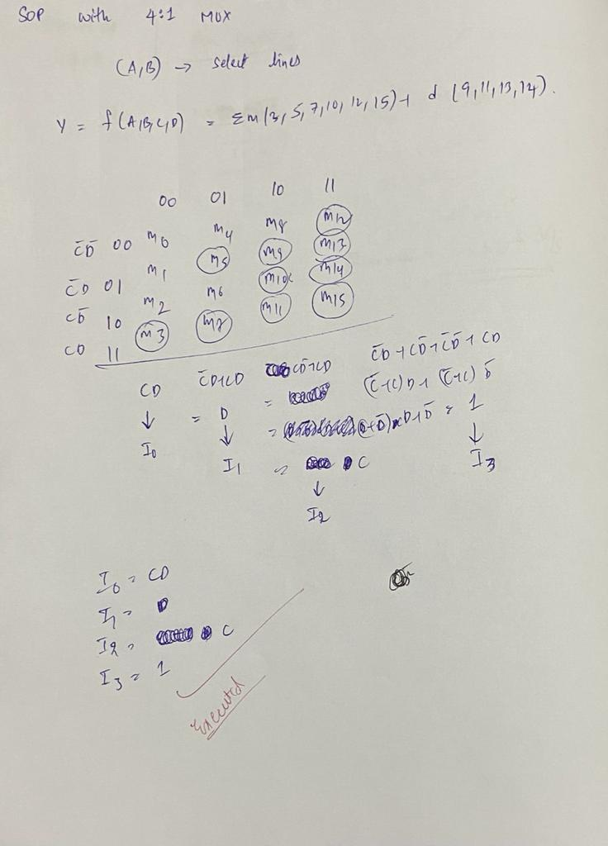

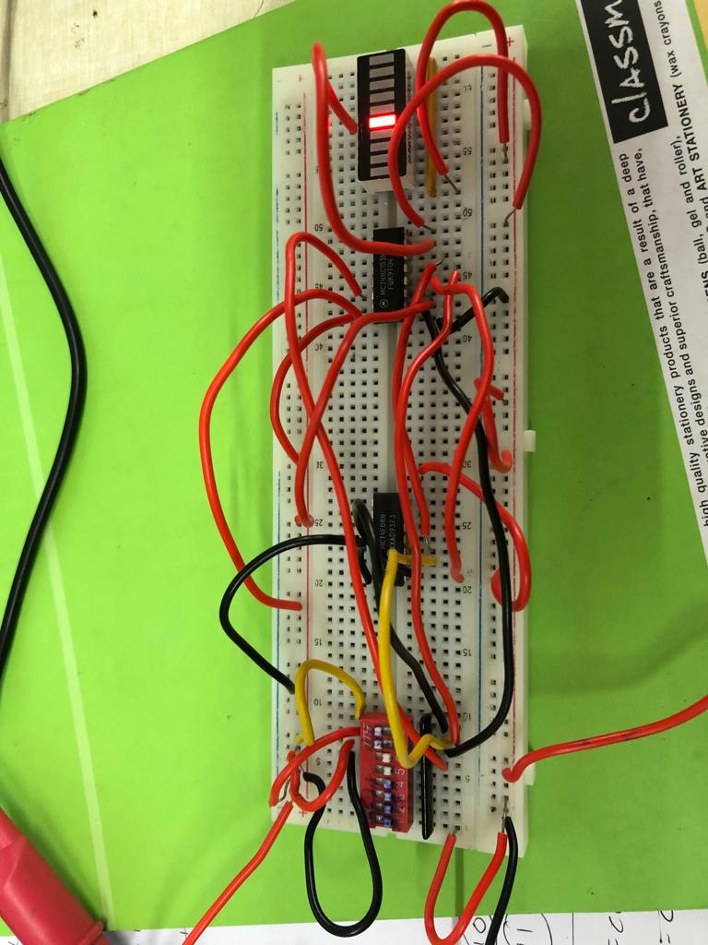
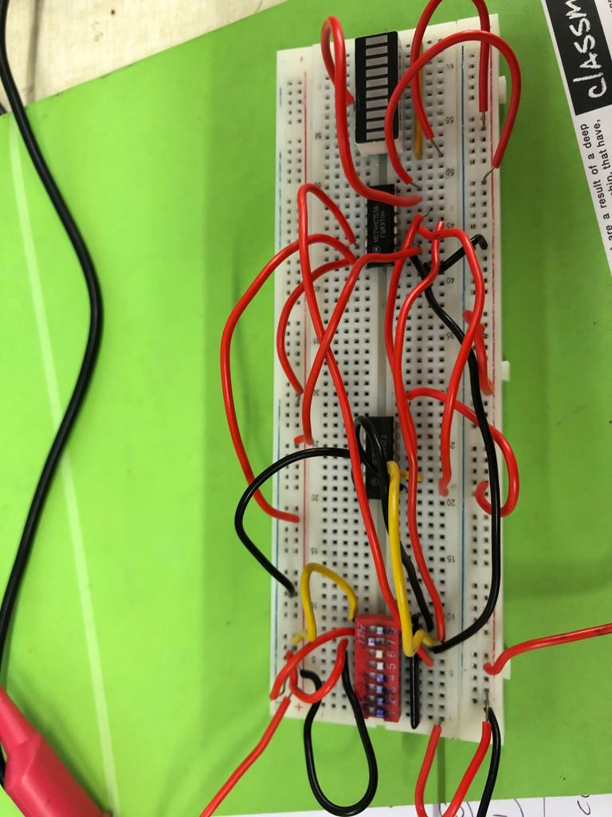
Snapshots of MUX implementation:

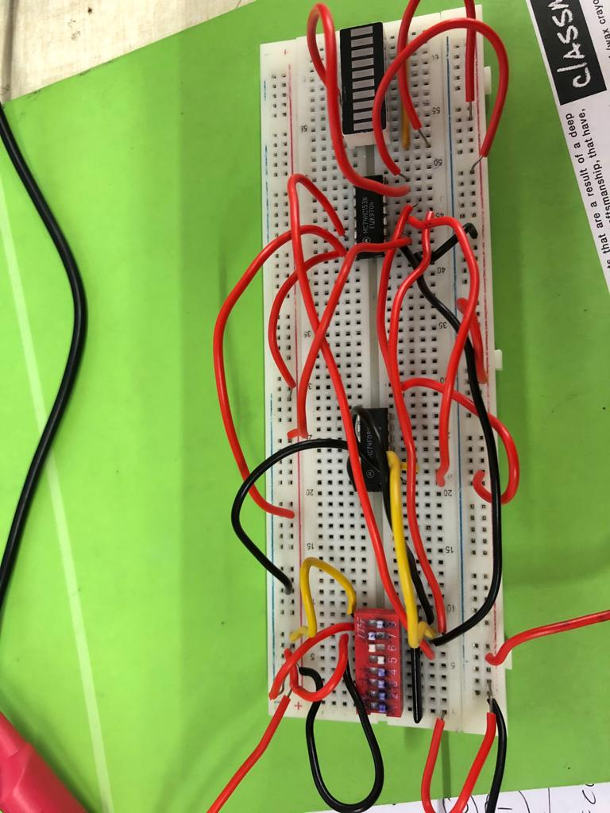
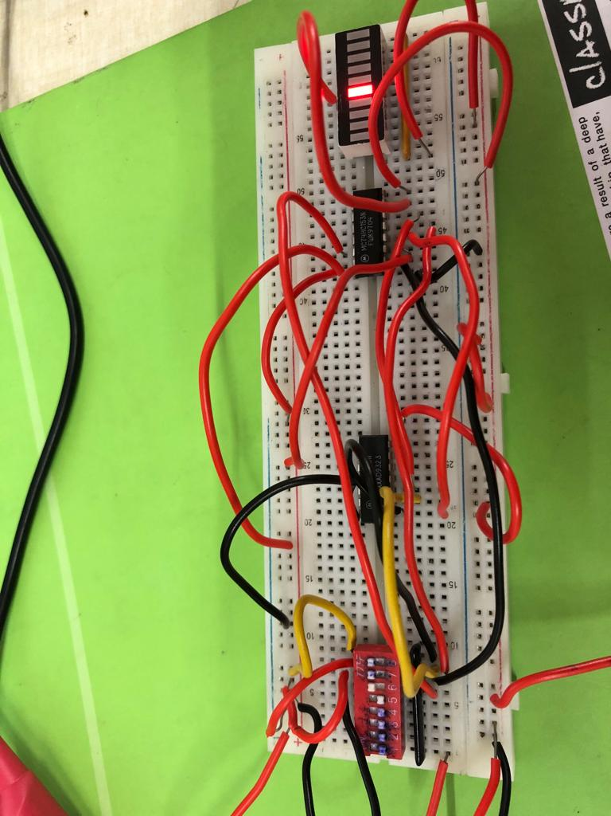

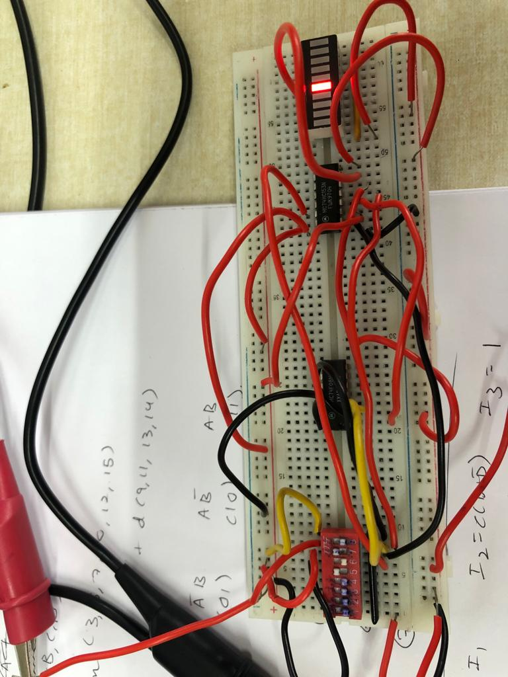
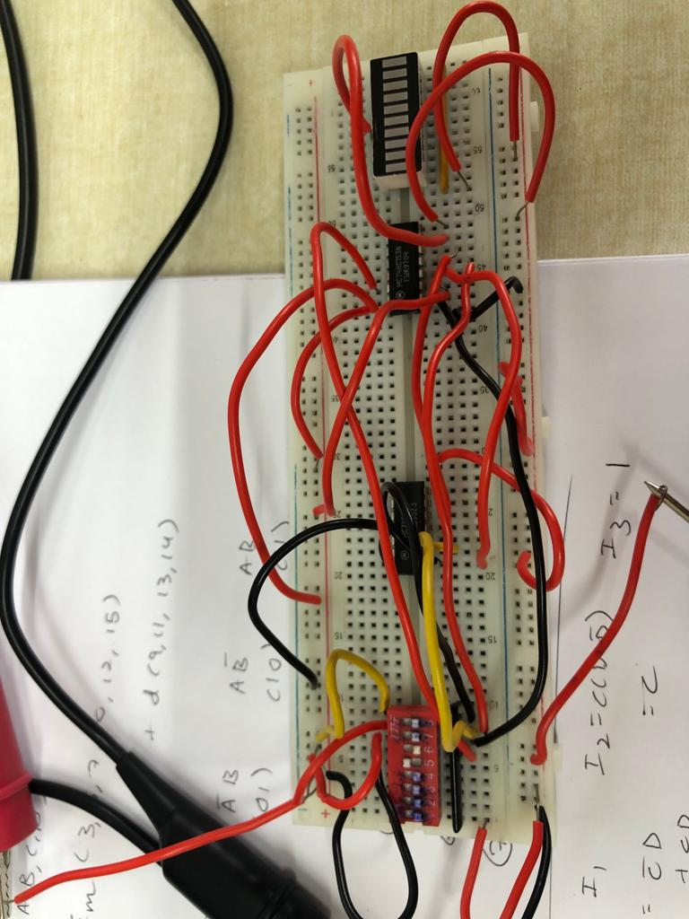

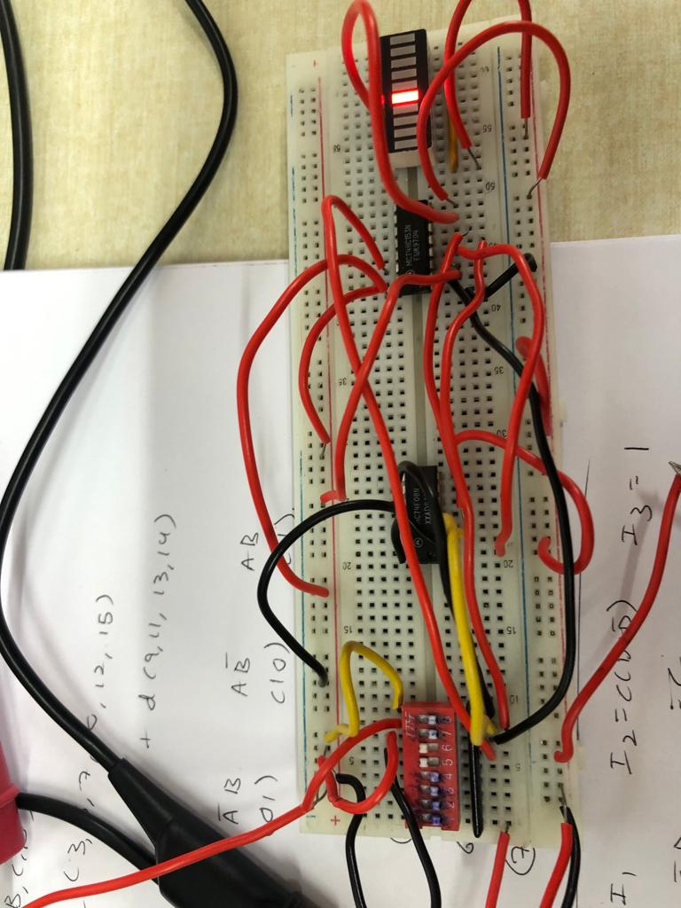
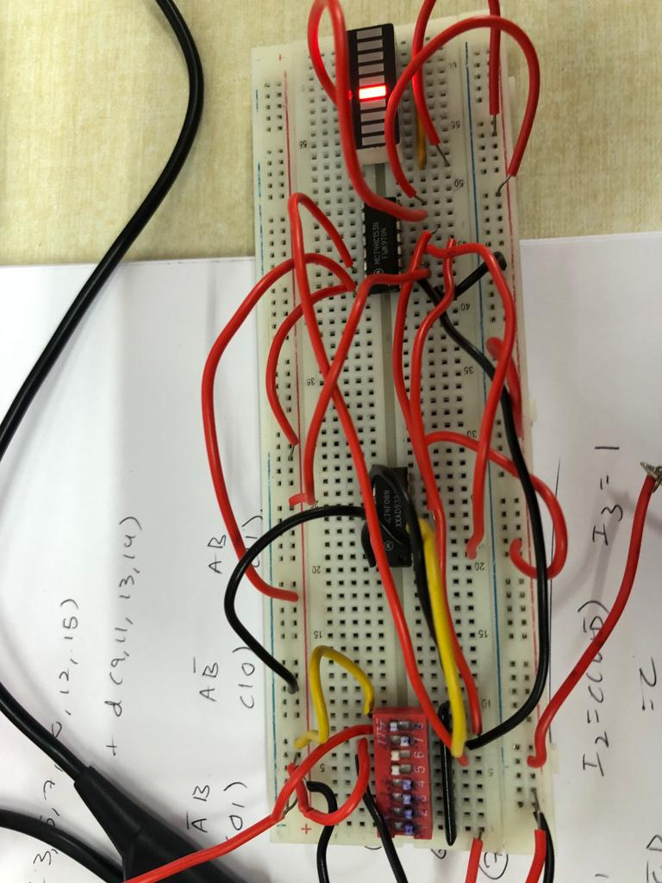

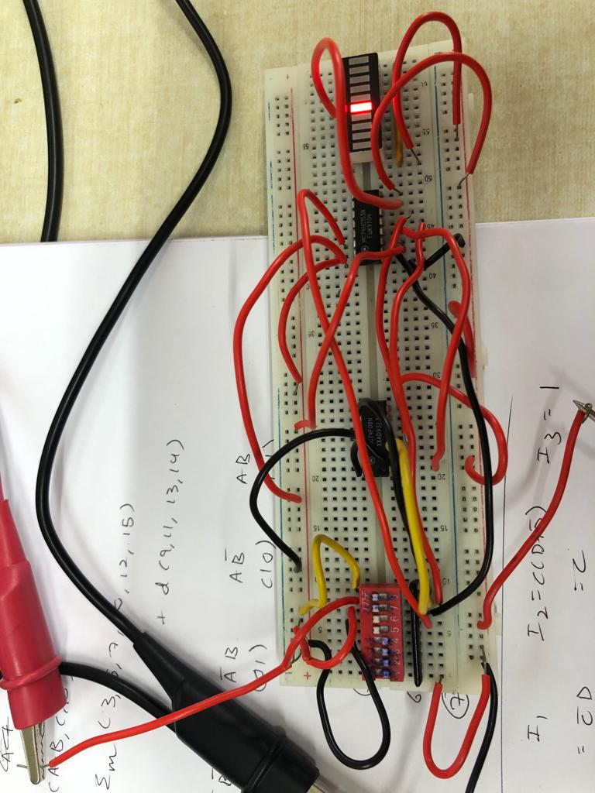

Decoder:

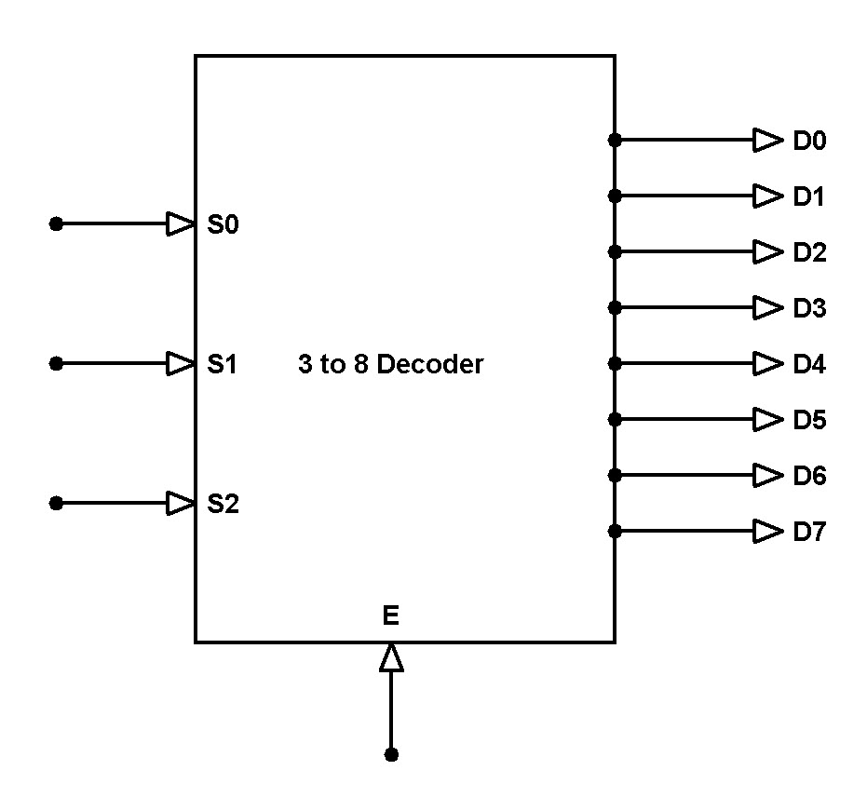

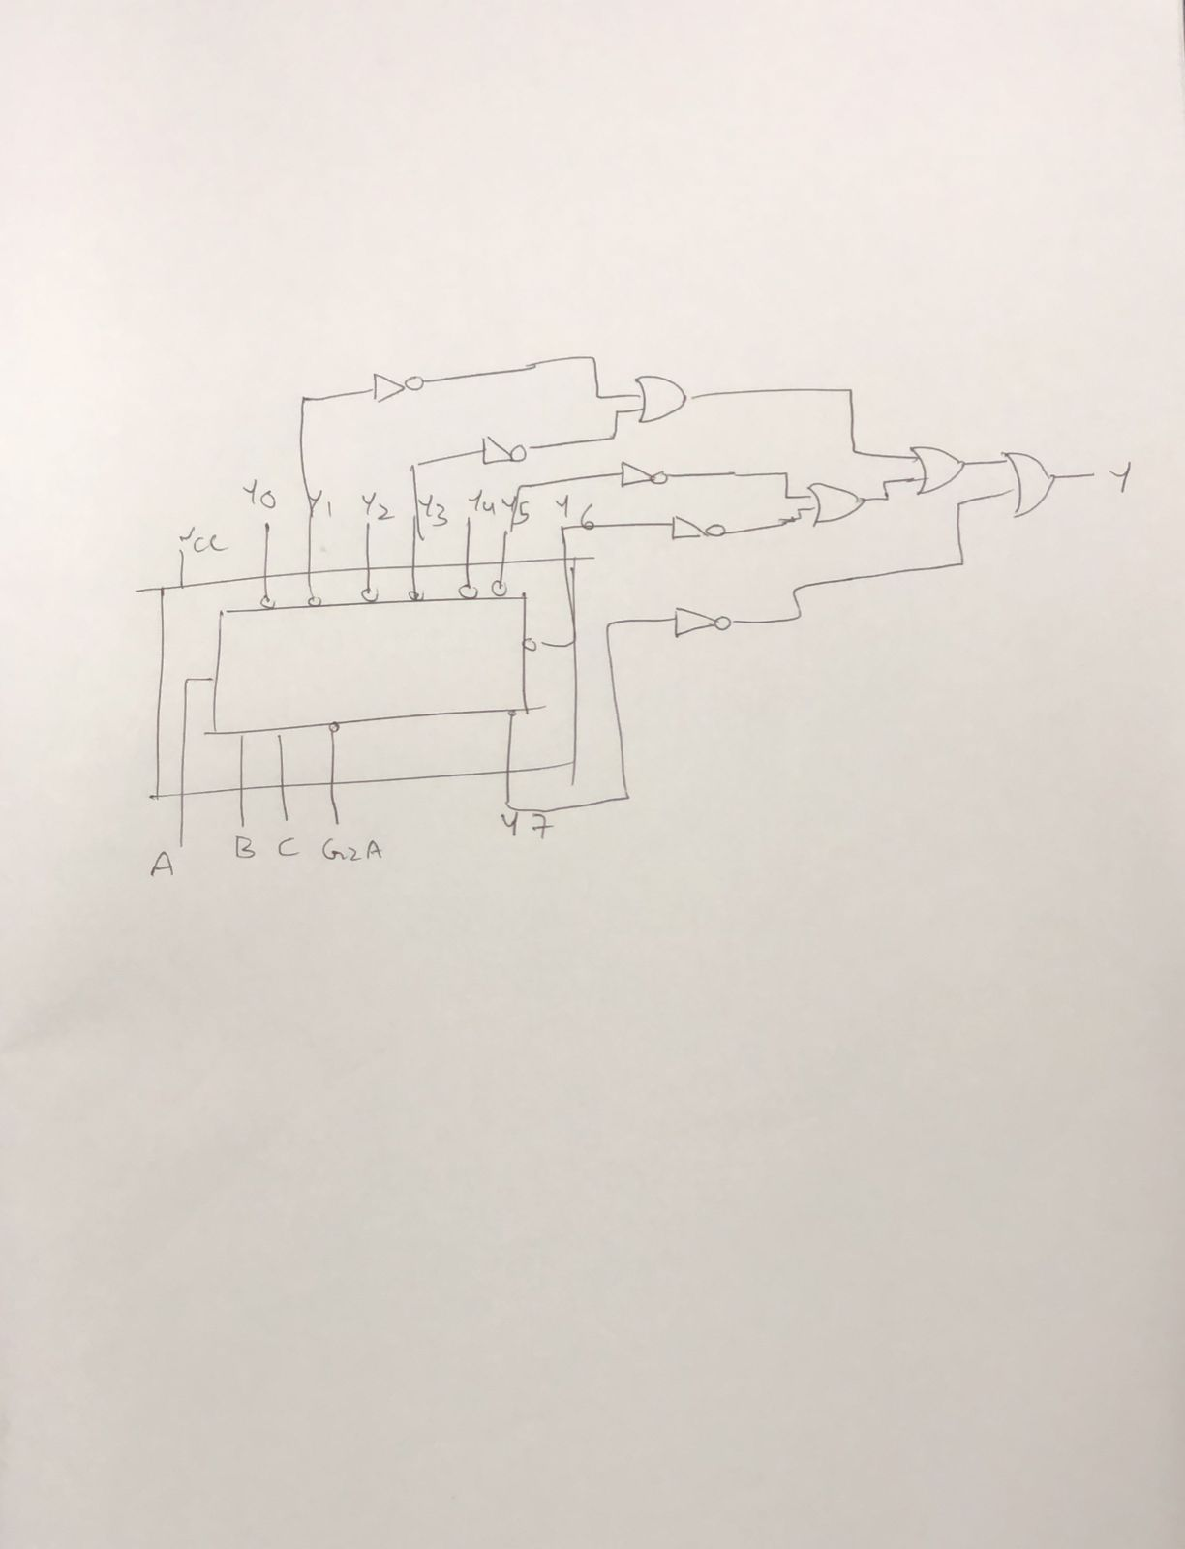
Design Procedure & Circuit diagram:

Results and Discussions:

The snapshots corresponding to each of the MUX states exactly represents the required logic represented by the minimized logic expressions. Hence we have implemented the following SOP with 4:1 MUX. Treat A, B as select lines (S₁,S₀).

Conclusions:

I’ve learnt that Digital IC MUX DM74153 and 3:8 Decoder can be used to implement SOP minimized boolean expression, obtained. The inputs for selector lines to Multiplexers are given via switches and the outputs are observed through LEDs. I explored the technicalities involved with multiplexers and decoders, and also learnt how to operate as per the SOP function.

